Our Ref: _______________ Your Ref: ________________________ Date: __________________

Baptist Church

Baale Yaku Site Area, P. O. Box 644,

Ogbomoso, Oyo State. Tel. 07052425407

Email: [newsprinbaptistchurch@gmail.com](mailto:newsprinbaptistchurch@gmail.com)

Website: newspringbc.comze.com

NEW SPRING

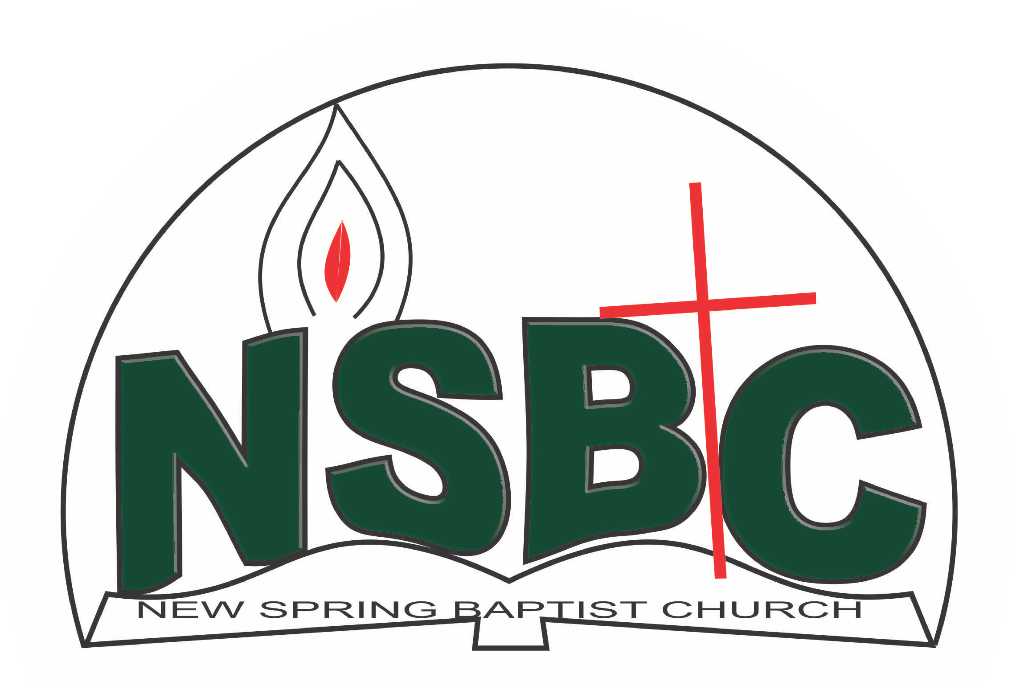

December 27, 2021

Dear Mrs. Ruth Olanrewaju,

Nomination to Serve as a Worker in the Church in 2022

Calvary greetings in the precious name of our Lord and Saviour Jesus Christ. It is our pleasure to inform you that, at the Church-in-Conference held on December 19,2021, the Church ratified your nomination to serve in the following areas between January 1 and December 31,2022:

1. Discipler
2. Member, Ecumenical Affairs under the Chairmanship of Mr. Bayo Babarinde
3. Member, Intercessors’ Committee under the chairmanship of Mrs. Funke Oyekunle
4. Chairman, Visitation Committee
5. Member, Mission and Evangelism under the leadership of Dn. Ayinde Ezekiel
6. Evangelism /Visitation coordinator, Women’s Missionary Union (WMU)
7. Member, Church Council

Please refer to the table below for the key functions of each of these roles. Details can be found in the Church constitution. You are strongly encouraged to become familiar with the tasks as stated in the document. There will be an orientation of the Church workers on January 15, 2022at 8:30 a.m. on the church premises. Please ensure you participate in this training.“Now it is required that those who have been given a trust must prove faithful. I Corinthians 4:2”. May God find you faithful in the task He has assigned to you.

| Domain | Key function of Office, Department or Committee |
| --- | --- |
| Discipler | To provide support to the Church Pastor in the ministry of the Church to ensure that members and regular worshippers are well equipped for every good work |
| Ecumenicical Affairs | To represent the Church and participate in the activities of umbrella organisationsthat the Church belongs to such as Christian Council of Nigeria, Bible Society |
| Intercessors | Responsible for standing in the gap on behalf of the Church and her members |
| Visitation | Visit members and worshippers at home or special institutions with a view to encouraging them in their Christian walk and reporting on pertinent issues that may require Church intervention and appropriate action |
| Stewardship/Service WMU | As directed by the WMU President |
| Church Council | It is the governing body of the Church whose membership, under the leadership of the Holy Spirit, holds one another mutually accountable with respect and love and see to the smooth running of the Church |
| Evangelism /Visitation coordinator, WMU | Responsible for the mobilization of WMU members for soul winning activities./ Visit WMU members at home with a view to encouraging them in their Christian walk and reporting on pertinent issues that may require Church intervention and appropriate action |

Thank you for accepting to serve in this Church.

Yours in His service

Olusayo Okediji Blessed Agboola

Church Secretary Chairman, Nominating Committee